**wStudents:**

Hatice Çankaya

Baki Akgün

Neslihan Çatak

**Examined Website:** AliExpress

**Website Link:** <https://www.aliexpress.us/?gatewayAdapt=glo2usa>

**Goal:** Lead global e-commerce with affordable products.

**Design Goals:**

* User-friendly interface
* Visually appealing product listings
* Comprehensive product descriptions
* Secure payment & buyer protection
* Multilingual & mobile-friendly platform

**AliExpress Website Review**

**First Impression**

Upon first opening AliExpress's website, the double-layered wide black navigation bar immediately catches the eye. Navigation bars are typically shorter and contain fewer connection buttons. This bar prominently features the language option and search engine. Next to the search bar, there is a QR code button that directs users to the mobile app.   
The buttons, backgrounds, and shapes have user-friendly rounded corners with smoother transitions rather than sharp edges, aiming to provide a more comfortable experience for the users.

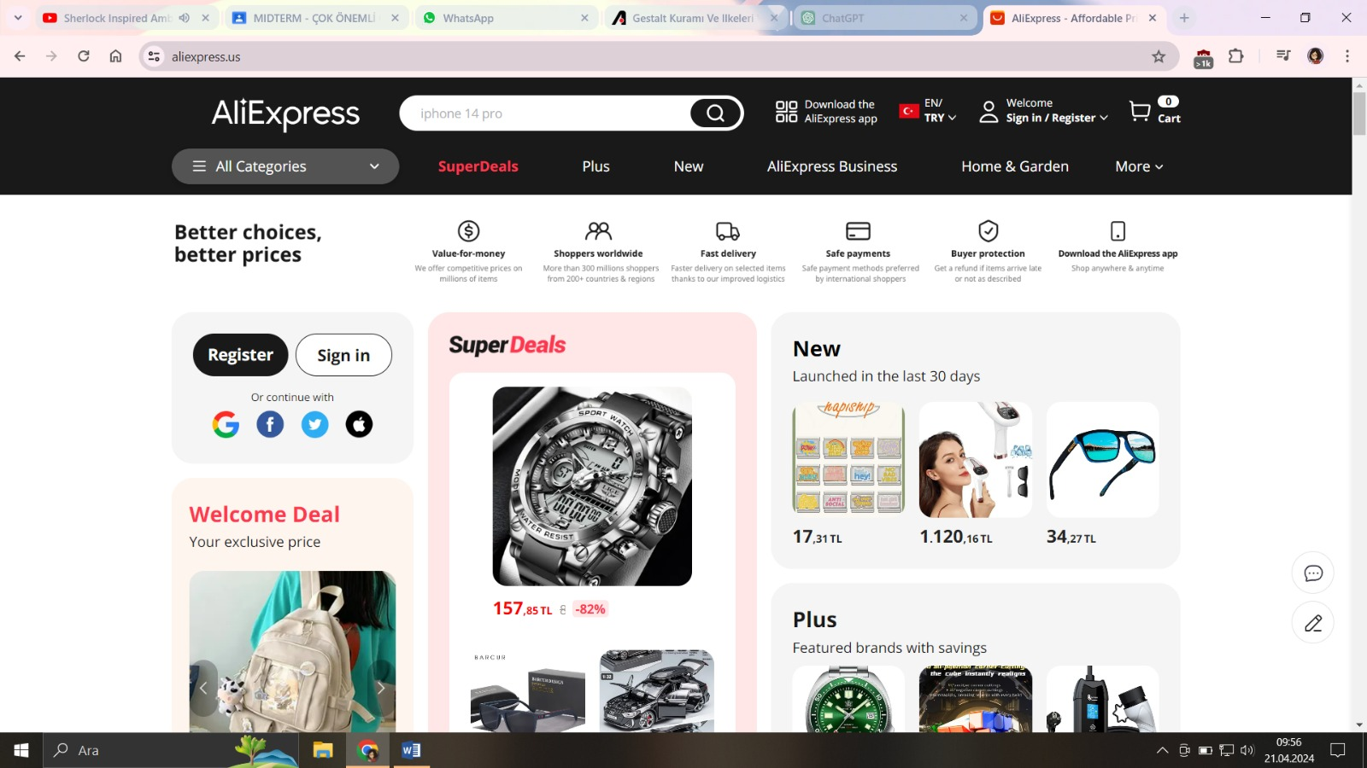

**Navigation and Search**

After a brief examination, the login and categories sections also come to the fore. These sections are designed functionally. In the categories section, desired products can be easily reached with directly opening category buttons. Under the navigation bar, the catalog of discounted products stands out. These products are quite affordable and attractive.

**Visuals and User Experience**

The visual addition of categories helps users find the products they are looking for more quickly. Up to this point, users can easily access everything they want. In terms of design, a simple design stands out, apart from the buttons and visuals. At the bottom are the best-selling products.

**Mobile App Integration**

When accessing the categories above the navigation bar, the navigation bar returns to its normal size and the products are presented in front of the user as on the homepage. Apart from the navigation bar templates, the interface appears functional and user-friendly. It can be said that directing to the mobile application with the QR code button also improves the user experience.

**Overall Evaluation**

AliExpress's website has an overall easy-to-use and user-friendly design. Elements such as the discounted product catalog and visual categories further enhance the user experience. Mobile app integration also facilitates users' shopping experience.

**Suggestions**

* The navigation bar design could be simplified a bit and contain fewer connection buttons.
* Further development of visual categories and the use of colors and icons can be considered to make categories more easily distinguishable.
* A more prominent button can be used instead of the QR code button for directing to the mobile application.

**Gestalt Principles**

**What are Gestalt Principles?**

Gestalt principles are a set of psychological principles that focus on the human tendency to perceive parts as a whole. They consist of a series of rules about how the human brain organizes and interprets visual information. These principles play an important role in design, art, psychology, and many other fields.

**Principles**

1. Figure-Ground: The focal point of your attention, or the shape your mind forms, is the figure. The surrounding ground fades into the background. Your visual perception is given meaning by the interaction of these two elements.

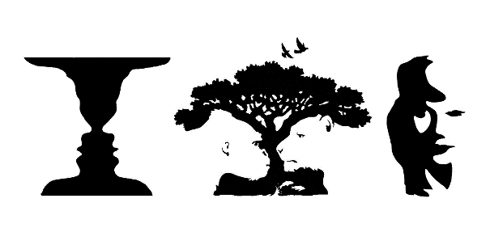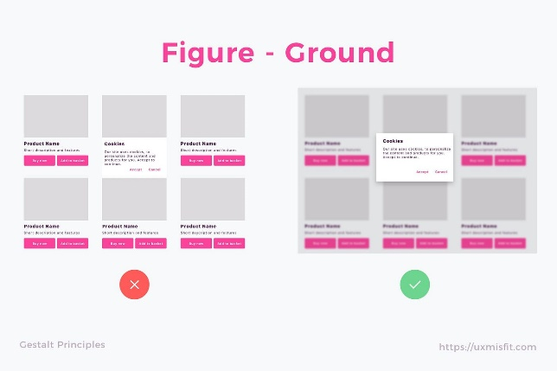

1. Proximity: Objects placed close together are automatically perceived as a group by your mind. This principle is also crucial in data visualization alongside the interface. By bringing together buttons or data in the same category, you can present information to the viewer more quickly and easily.

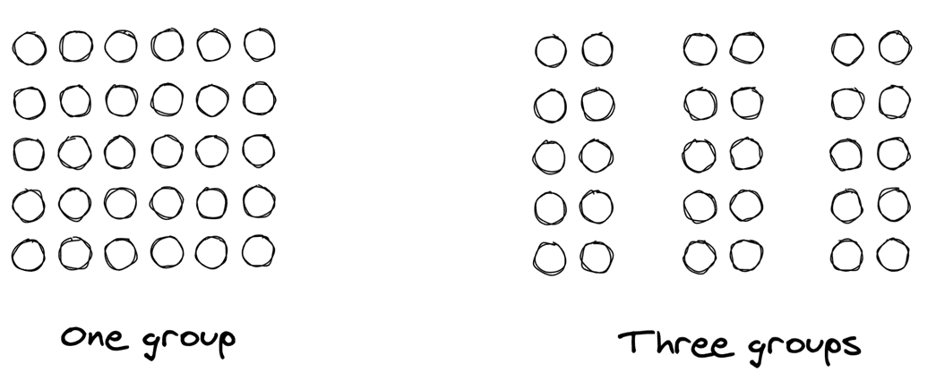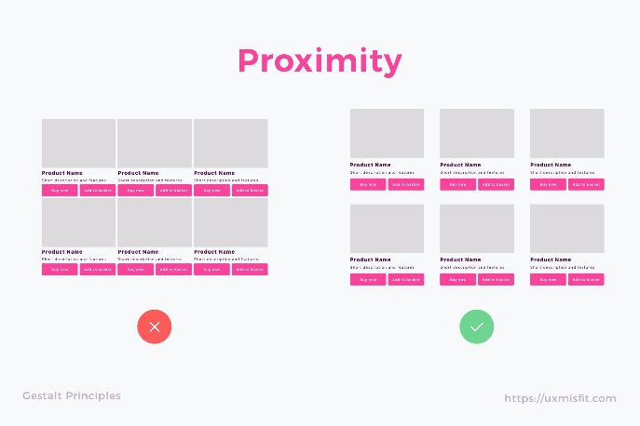

1. Similarity: Objects with similar characteristics come together in your mind. Elements such as color, texture, and shape help you group objects together.   
   There are various ways to perceive elements as similar and thus related. These methods include similarities in color, size, shape, texture, dimension, and orientation, with some being more effective in communication than others (e.g., color > size > shape). When similarity occurs, an object can be highlighted by being different from the rest; this is referred to as "Anomaly" and can be utilized to create contrast or visual weight. This approach helps draw the user's attention to specific content (the focal point) while aiding in scanability, discoverability, and the overall flow.

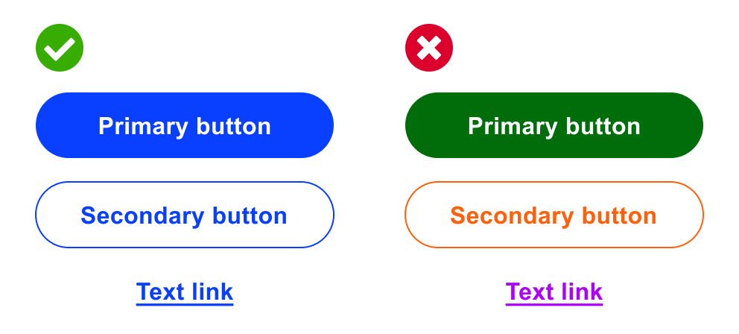

1. Closure: Like an incomplete puzzle, your mind tends to fill in missing information. Even incomplete or unfinished objects are perceived as complete. This principle is also used in logo and icon design. A simple and memorable logo can be easily completed and remembered by your mind.

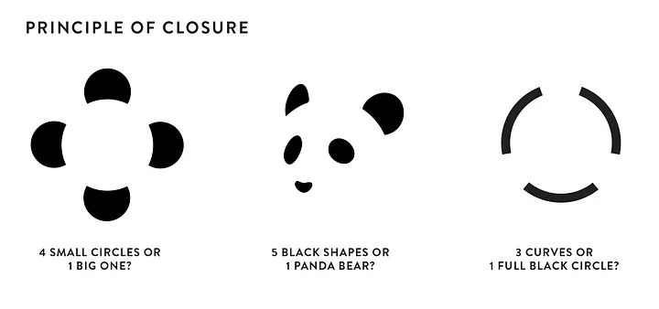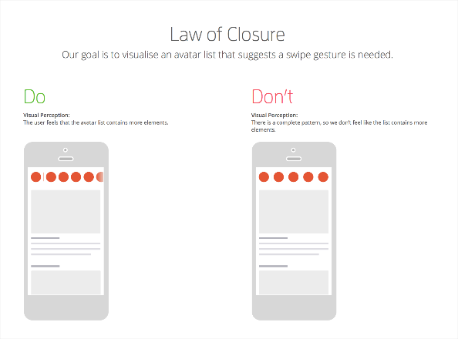

1. Continuity: The direction of a line is automatically followed by your mind. The principle of continuity is also quite important for web design and user experience (UX). We can also say that objects moving in the same direction tend to be perceived as a group.

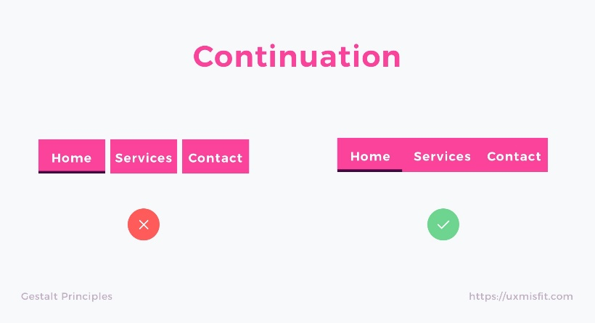

1. Simplicity: Complexity can tire your mind. The principle of simplicity helps you present complex information in a simple and understandable way for the interface. Instead of too much data and complex visuals, you can make it easier for the user to perceive the interface by using clear and concise plugins.

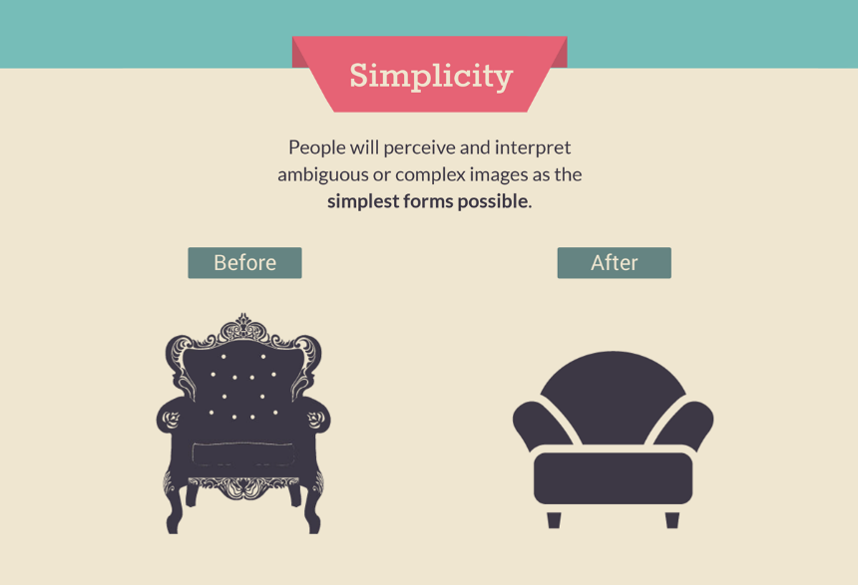

**Gestalt Principles in the Example of a Tree**

Figure-Ground: The tree is a distinct figure from the background, such as the sky.

Proximity: Branches and leaves are close to the trunk, perceived as a whole.

Similarity: The shape and color of the leaves allow us to perceive them as part of the same group.

Closure: Even with missing parts, our minds can complete the image of the tree.

Continuity: Leaves swaying in the wind are perceived as moving in a particular direction.

Simplicity: Despite its complex structure, the tree is perceived in its simplest form.

Summary: Gestalt principles help us understand how we perceive and interpret visual stimuli.

**Analyzing AliExpress Website According to Gestalt Principles**

1. **According to the Principle of** **Figure-Ground**

The darkening of the background when displaying the registration/login pop-up is a very good example of the figure-groundprinciple. Furthermore, when the second pop-up is opened, the previous one is dimmed, resulting in a more aesthetically pleasing appearance.

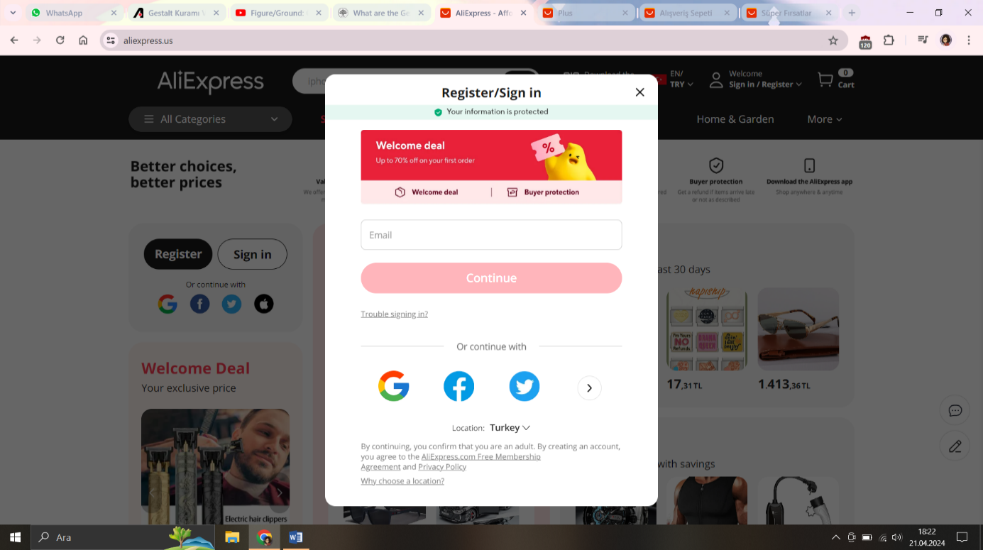

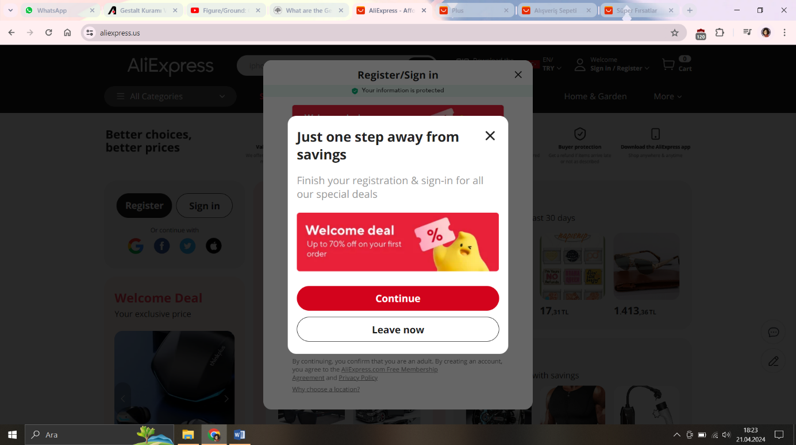

In the screenshots below, the application of the figure-ground principle is evident through the use of border shadows behind the opened menus.

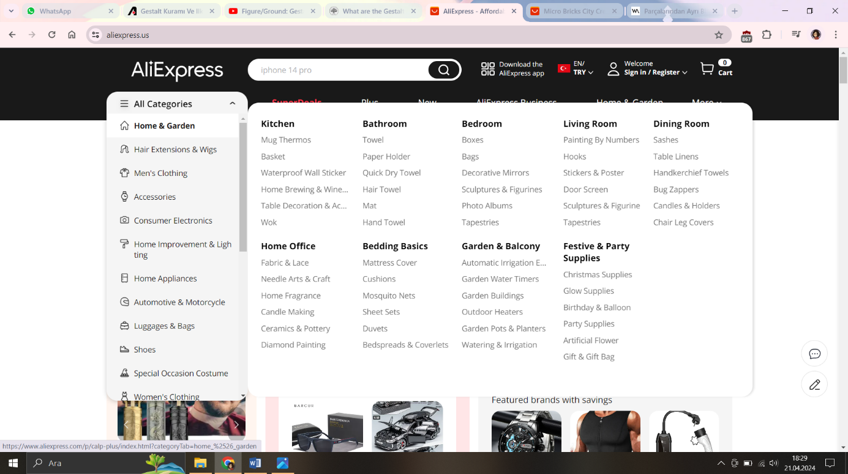

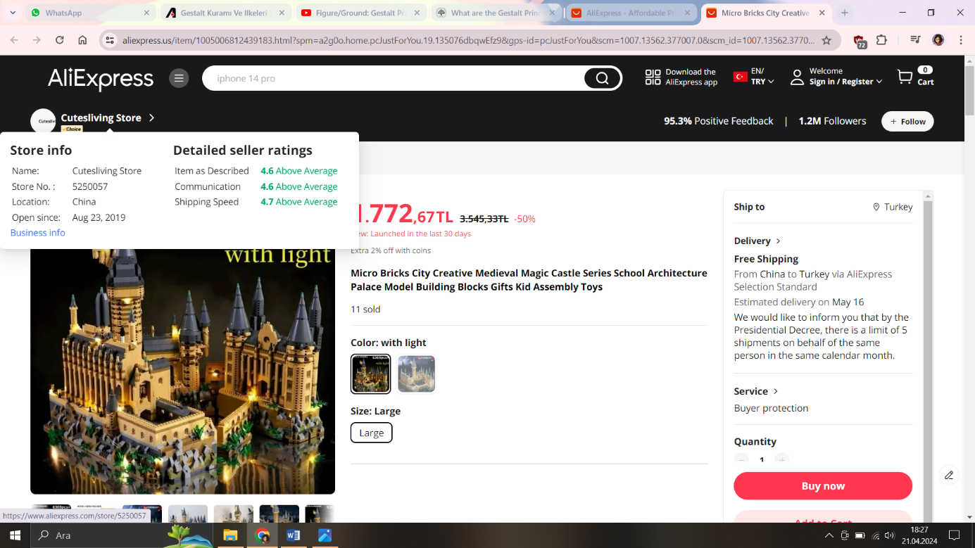

In the screenshots below, the figure-groundprinciple has not been applied. Like the ones above, applying a border shadow would have been necessary.

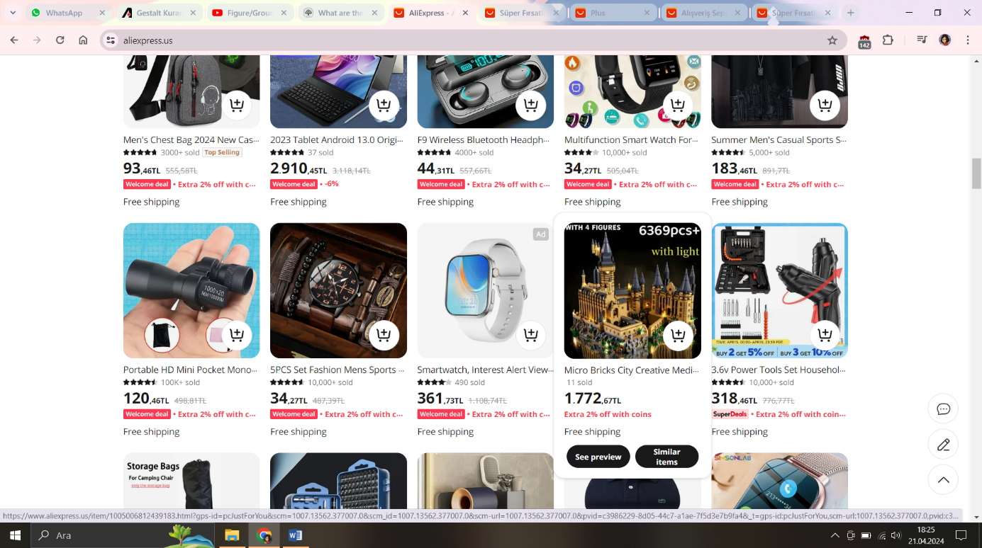

The use of different colors for the "Add to Cart" and "Purchase" buttons also adheres to the figure-groundprinciple.

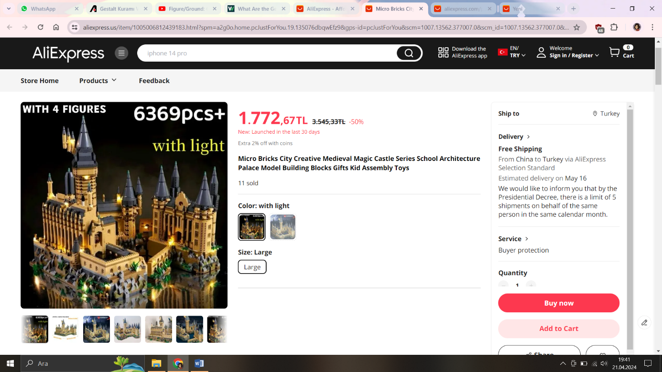

1. **According to the Principle of Proximity**





The equal and balanced spaces used in these sections, which we examined within the scope of similarity, are examples of the correct use of the proximity principle. In this way, it is easier for the user to perceive related elements in the same context.

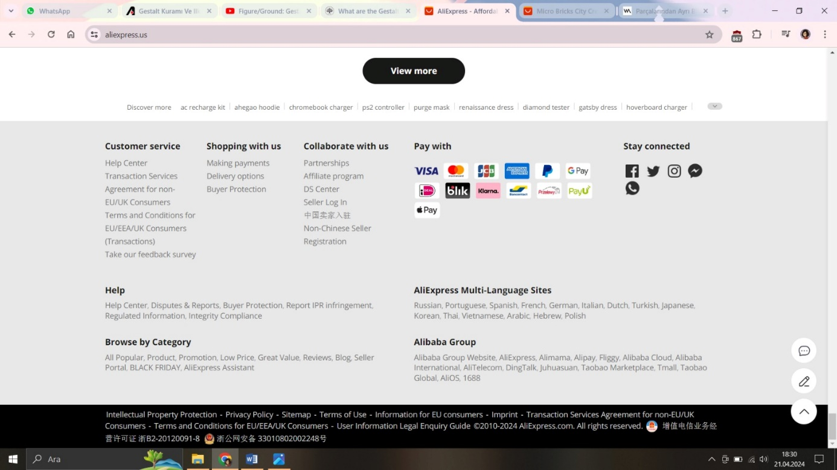

The footer above shows both a good use and a bad use of the proximity principle. 

In this section, the correct use of the similarity principle together with the proximity principle has made it easier for the user to find what they are looking for in the footer. Instead of examining all the elements, the user can find what they are looking for just by looking at the headings. Because the similarity and proximity principles are used very clearly and successfully. In this way, the user can easily perceive the groups. Although there are a lot of details, the user's focus is not lost thanks to successful grouping.



In this part of the footer, the proximity principle is not applied, resulting in a poor user experience. There is not enough space between the elements and there is too much space between the parts of the elements, especially at the end of the line, resulting in a very confusing structure. In addition, since there are elements using different alphabets, this confusion has increased even more. If the proximity principle had been used correctly in this section, a more understandable structure could have been presented to the user.

1. **According to the Principle of Similarity**



When we examine the part of the site seen above, the successful use of the law of similarity immediately catches the eye.



In order to make it clear that the element consisting of "All Categories" and hamburger icon is not a group with the elements next to it, the background color and text color are different from the other elements. The other elements give the user the perception that they are a group because they do not contain an icon and have the same background color. The element containing the “SuperDeals” text stands out more because it has a different font color than the others and directs the user's perception to itself. In this way, those who design the site manage user perception by using the principle of similarity.



In the line above, the image, title and text composition are used to create a perception that the elements are a group.



When we look at the two elements above, the icon and title parts that first attract the user's attention are on different subjects. However, the similarity of the icon structures, the same color and font size of the headings, and the same color and font size of the text sections create the perception that they are related to each other. This successful use of the similarity principle makes the user think of the features in the title section in the perception of AliExpress's advantages. Especially AliExpress, which stands out with its worldwide cheapness, supports the perception that "This element group contains the advantages of AliExpress" by putting the element containing the title "Value for Money" at the beginning of this group.

1. **According to the Principle of** **Closure**

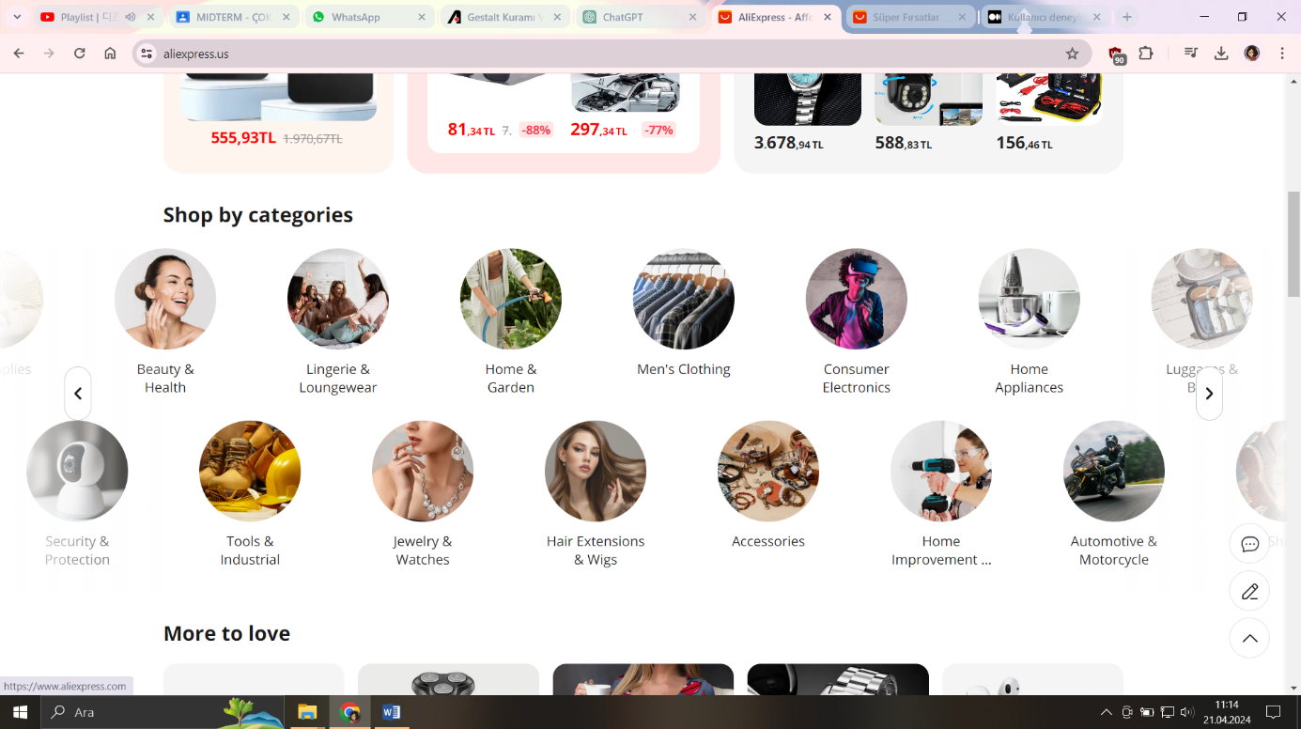

The fading of the right and left sides and the use of arrow indicators demonstrate the continuation of both sides, adhering to the principle of closure.

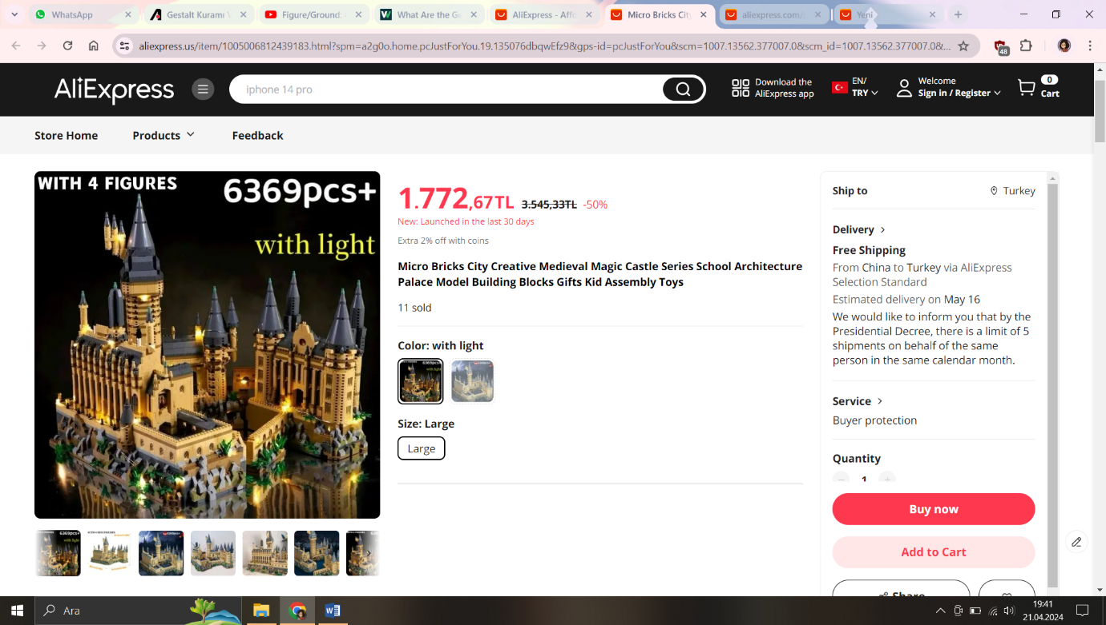

On the left side, the fading of the right and left portions in the display of sequential images below the main image indicates the continuation of the sequence on both sides, adhering to the principle of closure.

1. **According to the Principle of Continuity**

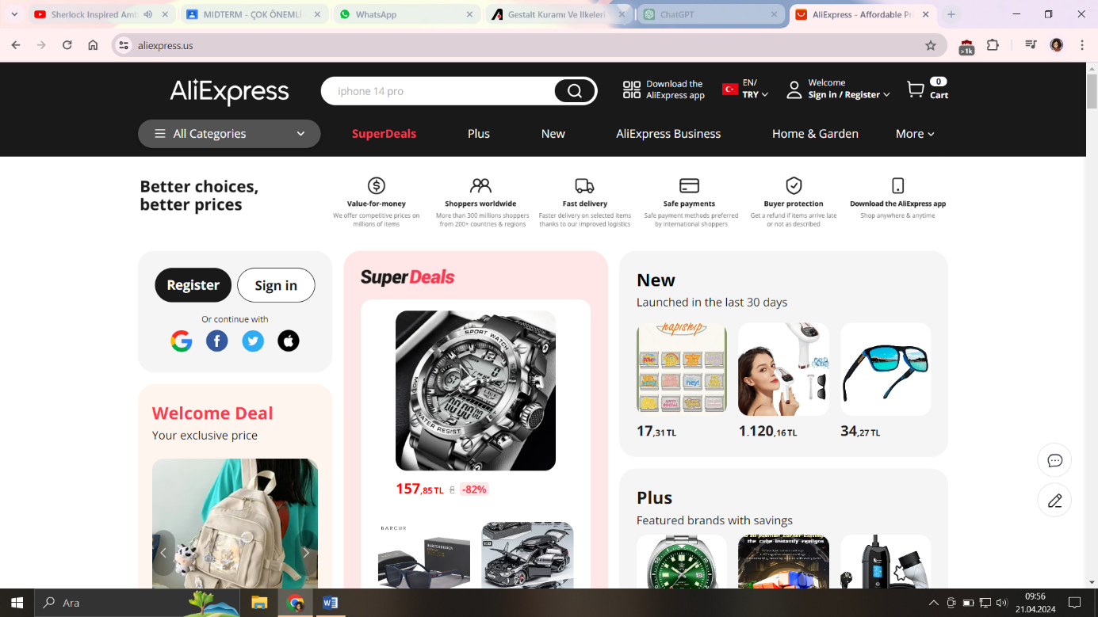

Starting from the top of the website, the alignment of the two-line navbar demonstrates the principle of continuity. Although the indentation of the name written in uppercase letters in the first line of the navbar doesn't start at the same position as the line below initially seems unfavorable, it actually provides a more aesthetically pleasing appearance by centering the dropdown menu below. Furthermore, the inconsistency in the indentation and end alignments of the navbar lines suggests that the two lines are not a continuation of each other, thus establishing a form of continuity within themselves.



(örnek)

(2)

(1)

If we examine the examples I gave above, the example of the icon that is activated can be seen very clearly because it is more suitable for the icon.

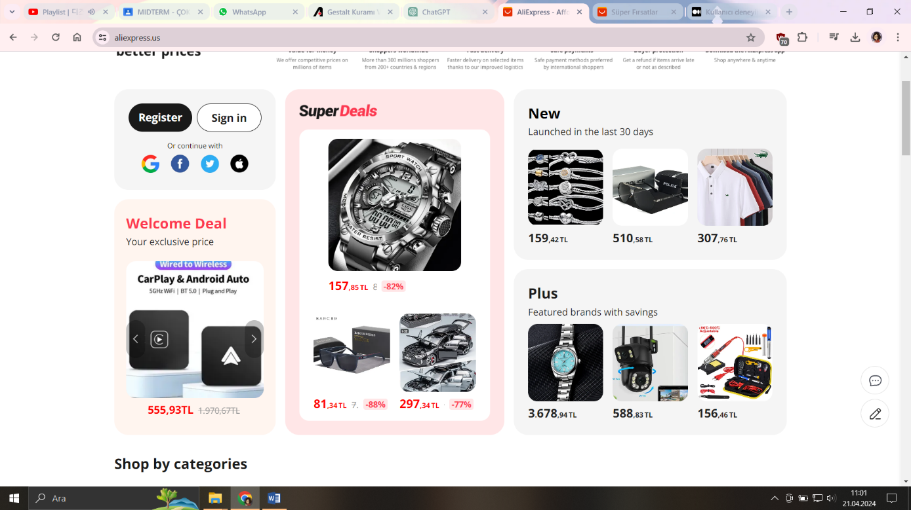

When we look at the boxes of different colors and shapes, it's quite clear that they don't provide continuity with each other, as each represents a different category/page. Therefore, the boxes are in different alignments, sizes, and colors. The size and shapes of the product images within each box indicate the continuity of those products.

The first social media icon inside the top-left box being larger than the others indeed disrupts the principle of continuity. However, aside from this discrepancy, this section has been prepared in accordance with the principle of continuity.



The fluid movement and alignment of the categories create a nice example of continuity.

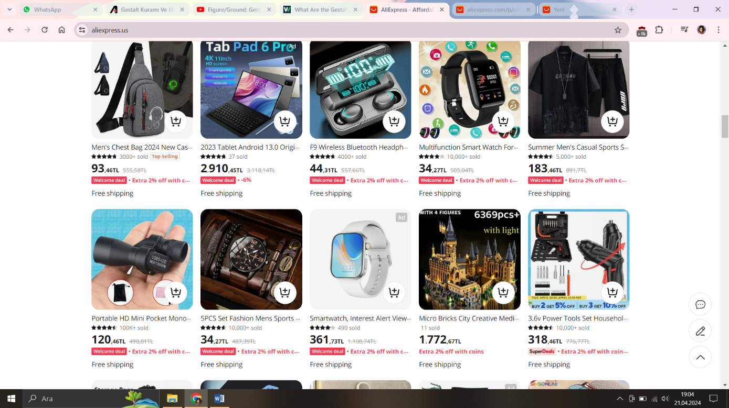

The products are displayed simply without any frames, maintaining continuity with the images and card styles.

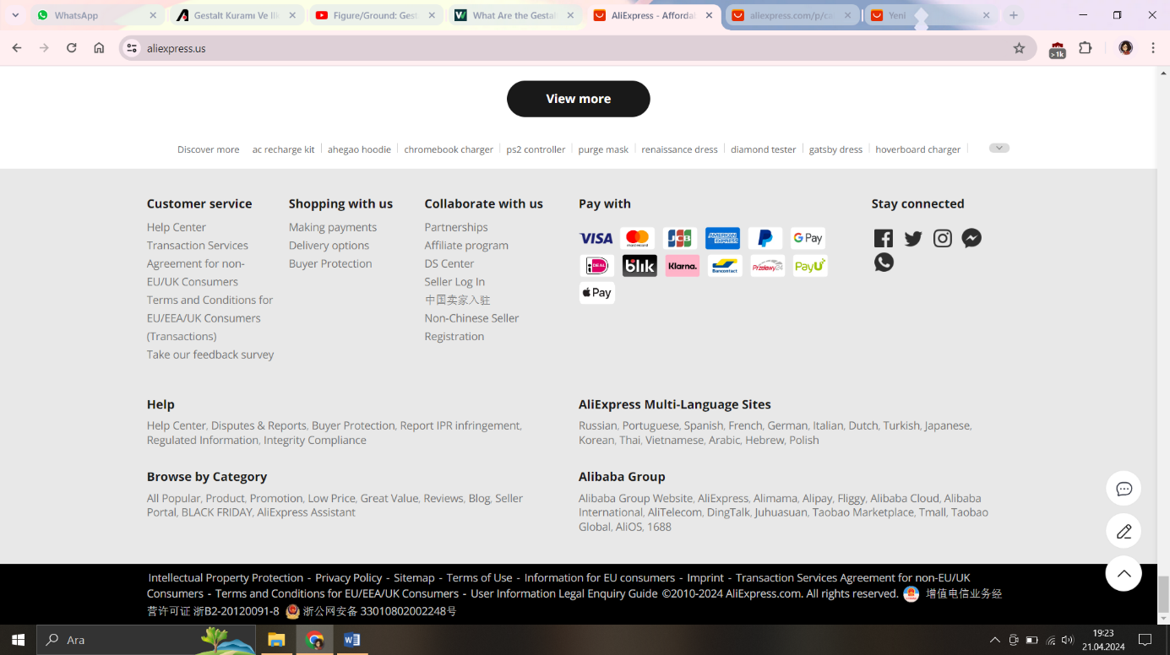

At the bottom of the homepage, just above the footer, there is a line with dashes between each statement, which, although it violates the principle of continuity, is necessary to prevent the statements from blending into each other without the dashes. Regarding the footer, it is generally divided into two columns. The alignment of the rows and the cohesive selection of icons demonstrate the application of the principle of continuity.



If we look at the product page, there is another lighter-colored navbar below the main navbar, which makes navigation easier on the website.

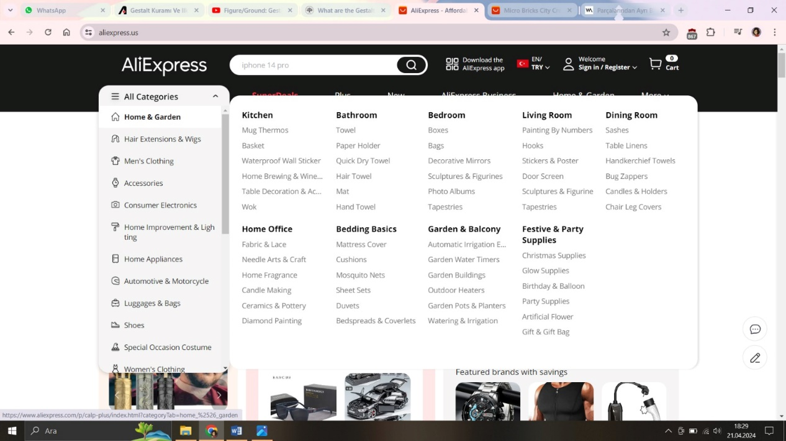

1. **According to the Principle of Simplicity**

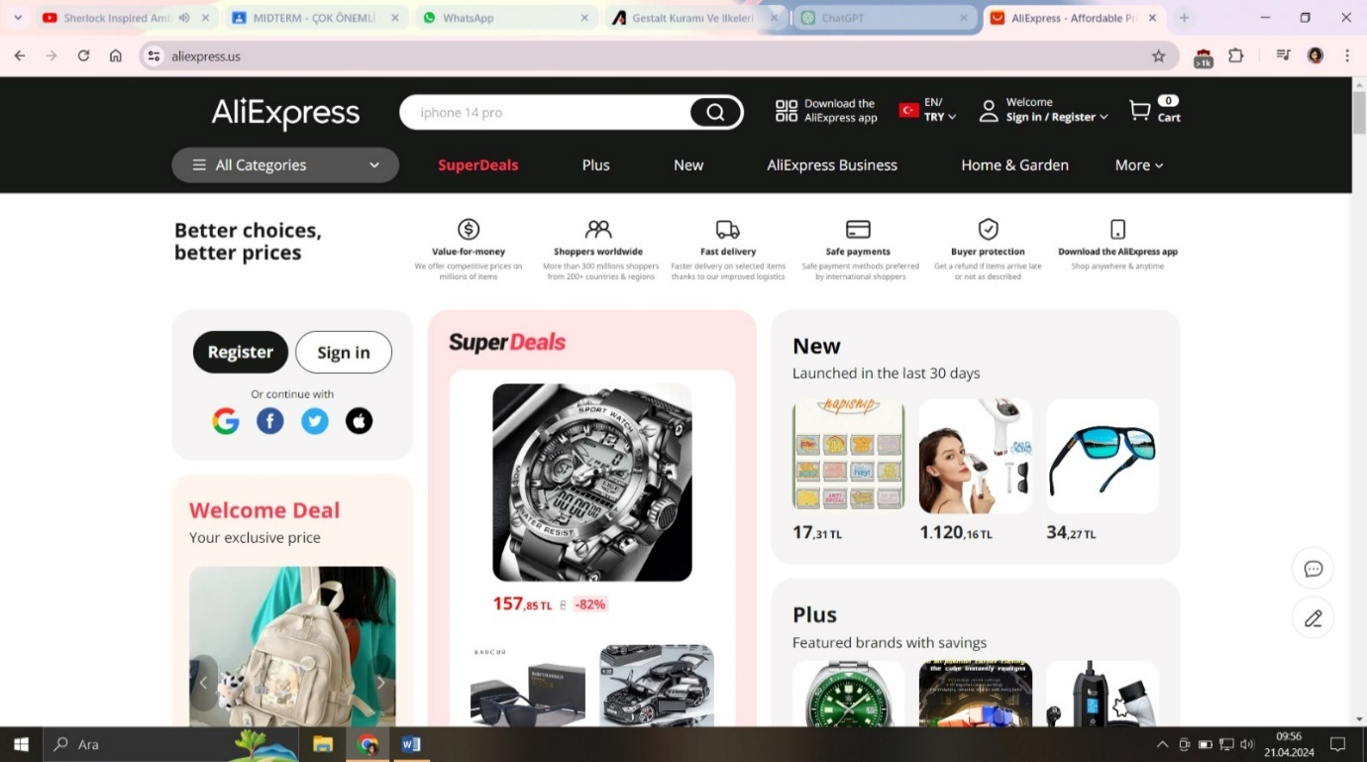



The icons used in the examples above are chosen to be as simple as possible and to support the meaning of the text next to them. In this way, these parts of the web page have been kept from being boring without cluttering the web page. Undoubtedly, the selection of icons based on the principle of simplicity instead of being complex and colorful has had a very positive impact on the user experience.



In the section used above, logos, which are known to be in the perception of almost all users, are used to prevent text clutter in the footer section. This can be shown as an example of a good use of the principle of simplicity.

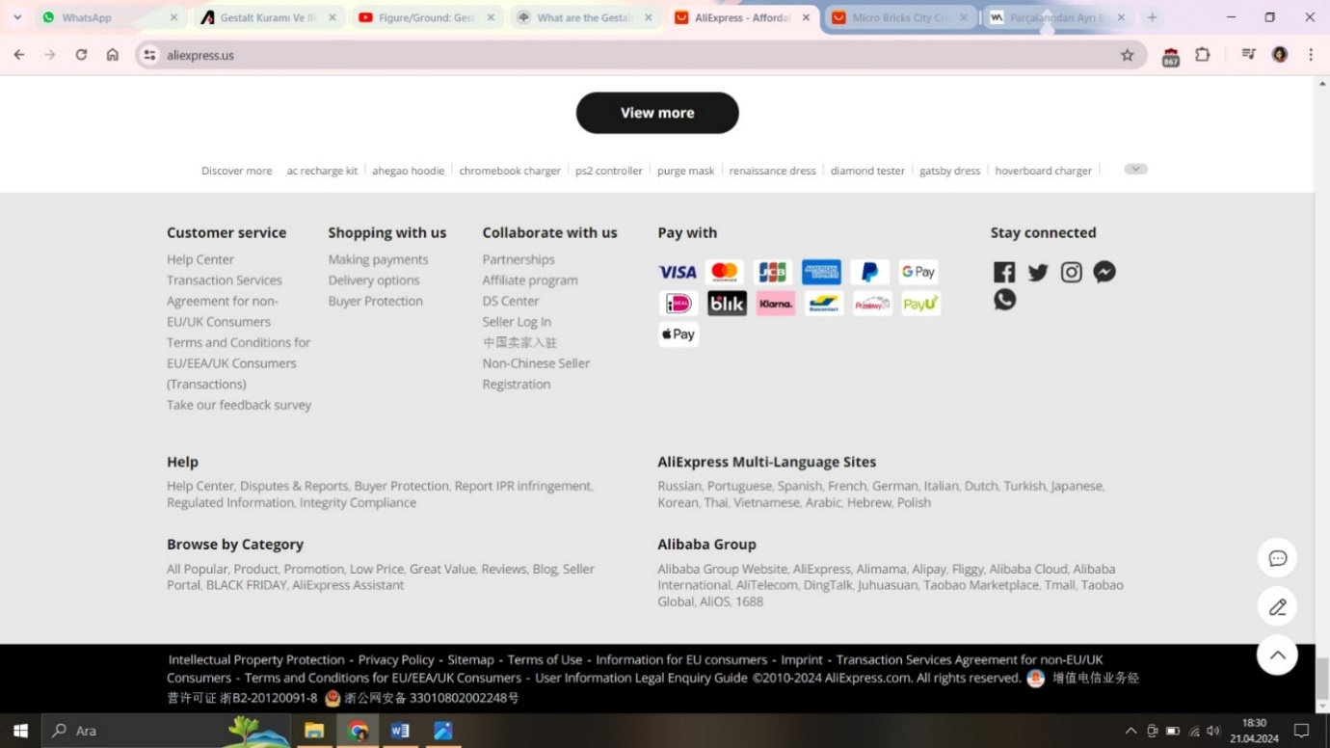The logos used in the bottom right of the next photo are also an example of the correct use of the principle of simplicity. The use of three simple icons instead of pop-ups or texts that take up most of the large screen and draw the user's perception to themselves has prevented the user's perception from being distracted. Thus, the user stays on the site longer and the user focus is directed to more important purposes for the site, such as "purchasing".

**Summary**

**Issues**

* In the "Products" tab, the first social media icon inside the top left box disrupts the principle of continuity in that area due to its larger size compared to the other icons.
* In the "Categories" tab, the principle of figure-ground is not applied. Border shadow similar to the one in the pop-up should have been applied.
* The similarity in icon structures, the uniformity of title colors and font sizes, as well as the consistency in text colors and font sizes, create an impression of interrelatedness to the user.
* While there may be complexity in some areas in terms of proximity, clarity compensates for this gap.
* There is a poor user experience in the footer section due to the inconsistent spacing, which goes against the principle of proximity.

**Results**

* Although there seem to be some minor issues in some places at first glance, the design aligns well with the principles of closure and continuity.
* The darkening of the background when pop-ups open and other background choices adhere to the figure-ground principle.
* Besides the mentioned errors, the site has been designed according to the principle of similarity and adheres to this principle.
* As observed in the principle of similarity, the principle of proximity has also been appropriately utilized.
* In accordance with our final principle, everything has been appropriately used according to simplicity.
* Although there are minor inconsistencies on the Aliexpress website as mentioned above, it is ultimately a website that adheres to Gestalt Principles.

Sources

**-**[**https://www.innova.com.tr/blog/gestalt-kurami-ve-ilkeleri-veri-gorsellestirme-icin-nasil-kullaniliyor**](https://www.innova.com.tr/blog/gestalt-kurami-ve-ilkeleri-veri-gorsellestirme-icin-nasil-kullaniliyor)

-[Gestalt İlkeleri Nelerdir? (www-verywellmind-com.translate.goog)](https://www-verywellmind-com.translate.goog/gestalt-laws-of-perceptual-organization-2795835?_x_tr_sl=en&_x_tr_tl=tr&_x_tr_hl=tr&_x_tr_pto=sc)